\*Writer's Blog React App\*

-installed node js .(compiler)

-installed v.s.code.(editor)

-npm(package installer)

-To create app environment installed supported files with the help of create-react-app command.

-Designed ui.

Navbar

Heading

Header Image

Posts Sidebar

-created navbar, left side social media icon ,in middle section Home,About, Contact,write,Login and in right side logo and search icon.

-Below navbar, Heading(smile and start) and header image.

-Posts section and sidebar

-Files:

Public folder

index.html

images

Src folder

App.js

index.js

topbar

Topbar.jsx

topbar.css

header

Header.jsx

header.css

Posts

Posts.jsx

posts.css

Post

Post.jsx

post.css

sidebar

Sidebar.jsx

sidebar.css

Topbar:



Header:



Posts and Sidebar section:

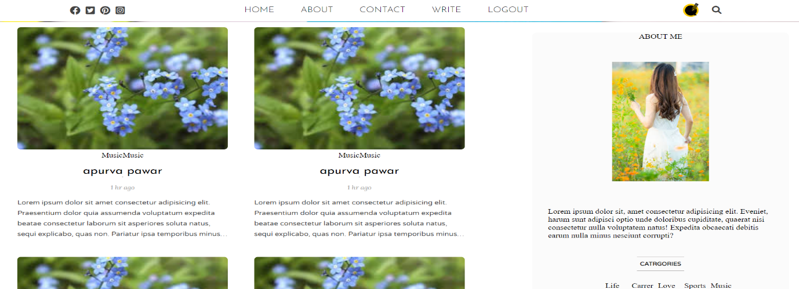

-Code: